Hunt S.A.F.E. Partner Web Copy

Hunt S.A.F.E. to Prevent Firearms Accidents

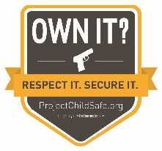
Proper firearms storage is the #1 way to prevent firearms accidents. With this in mind (NAME OF AGENCY) is working with the National Shooting Sports Foundation (NSSF) to remind hunters that “The Hunt Isn’t Over Until You Are S.A.F.E.”

S.A.F.E. stands for Store your firearms responsibly when not in use; Always practice firearms safety; Focus on your responsibilities as a firearms owner; and Education is key to preventing accidents.
The hunting season is a time of year when a lot of firearms are in use and in transport, so we urge hunters to remember what they can do to prevent firearms accidents in the field, at the range, at home and everywhere in between.

To complement (STATE’s) hunter safety programs and provide you with additional resources on proper firearms storage and safety, the National Shooting Sports Foundation, as part of its Project ChildSafe program, has made several resources available, which can be found (ON AGENCY’S WEBSITE / ON THE PROJECT CHILDSAFE WEBSITE), including:

- Tips and guidelines on safe firearm handling
- NSSF’s Ethical Hunter brochure.
- An infographic with guidelines on a variety of firearm storage options
- Information on where to get a free firearm safety kit including a cable-style gun lock

The idea is to help everyone hunt responsibly, return home safe and securely store their unloaded firearms. Together we can help prevent firearms accidents.

# # #

